40277000664
Community Development Director
Mark Hofman

17425 Ballinger Way NE
Lake Forest Park, WA 98155-5556
Phone: 206-957-2824
Email: mhofman@cityoflfp.gov
www.cityofLFP.gov

PUBLIC NOTICE
NOTICE OF DECISION FOR MAJOR CRITICAL AREA PERMITS
_____________________________________________________________________________________

File Number: 2023-CAMJ-0009 and -0010
Applicant/Agent: Sound Transit; Dangelei Fox
Location of proposal: Bore Hole #38 is located on a rear slope area of an existing developed residential lot at 15630 38th Ave NE (Parcel No. 6744700303), adjacent to and west of Bothell Way (SR 522). Bore Holes #30 and 35 are located in the paved parking area of the Woodland North Apartment complex at 3615 NE 155th St (Parcel No. 6744700101), adjacent to Bothell Way.

Current Approved Project: This Notice of Decision specifically pertains to approval (attached) of major critical area permits to bore for geo-technical investigation at locations within two developed residential private parcels adjacent to Bothell Way. These locations are also located within regulated critical areas/buffers. The purpose of the borings will be to provide data for further studies associated with land use submittals for a future SR 522 Bus Rapid Transit project.

Other Approvals Needed: See Conditions of Approval regarding right of way permits.

Environmental Review: The scope of each excavation does not meet the threshold for a SEPA determination, although Sound Transit has claimed lead agency status for this project. Minor site exploration of this type is normally exempt per WAC 197-11-800.

Additional Information: Additional information may be obtained by contacting the Lake Forest Park Community Development Department at (206) 368-5440 or at the City’s Notices and Announcements webpage (https://www.cityoflfp.gov/313/Notices-and-Announcements). Materials related to this proposal and decision may be reviewed at City Hall Monday – Friday, 9:00 am - 3:00 pm. Contact Mark Hofman, Community Development Director, at mhofman@cityoflfp.gov or (206) 957-2824, if you prefer to make an appointment to review the materials with a planner’s assistance.

Appeals: This Type-III decision by the Community Development Director (Code Administrator) may be appealed to the City’s Hearing Examiner per LFPMC 16.26.190, Type III - Appeal. To do so, submit a written appeal statement to the City Clerk, Matthew McLean, at 17425 Ballinger Way NE, Lake Forest Park, WA 98155, along with a $500 filing fee no later than the fourteenth day following the date of publication of this decision. You should be prepared to make specific factual objections in your written appeal.

File Number: 2023-CAMJ-0009 and -0010
Applicant/Agent: Sound Transit; Dangelei Fox
Location of proposal: Bore Hole #38 is located on a rear slope area of an existing developed residential lot at 15630 38th Ave NE (Parcel No. 6744700303), adjacent to and west of Bothell Way (SR 522). Bore Holes #30 and 35 are located in the paved parking area of the Woodland North Apartment complex at 3615 NE 155th St (Parcel No. 6744700101), adjacent to Bothell Way.
Proposed Sites (not to scale):
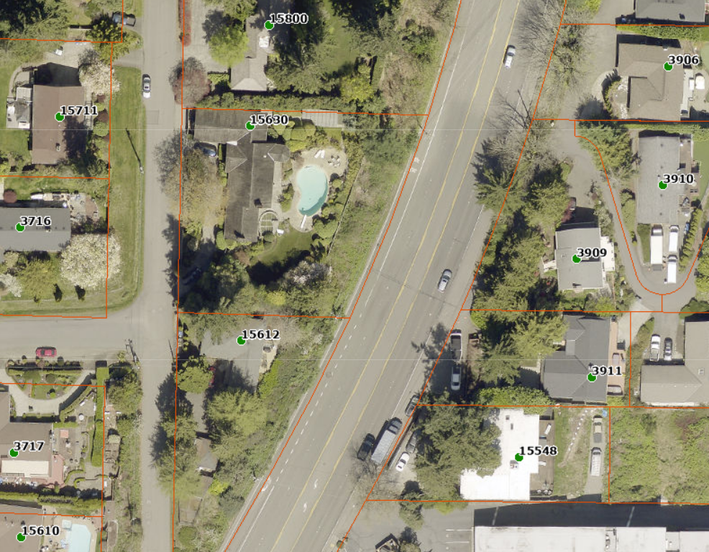
PROJECT SITE
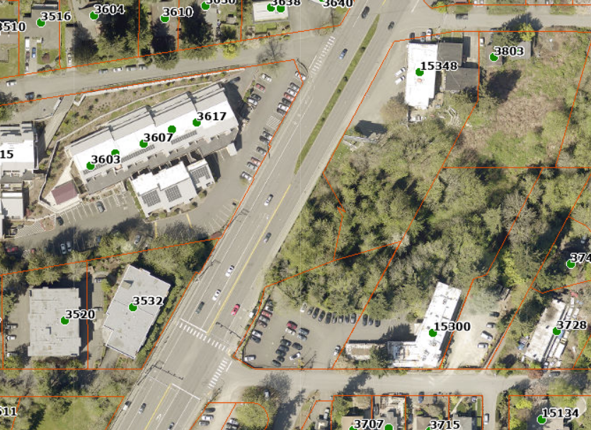
PROJECT SITE

